To open the simulator on windows simply click on the included simulator.exe application, to open on mac follow the included instructions and return here when you have it open.

When you have it open you will see the following screen

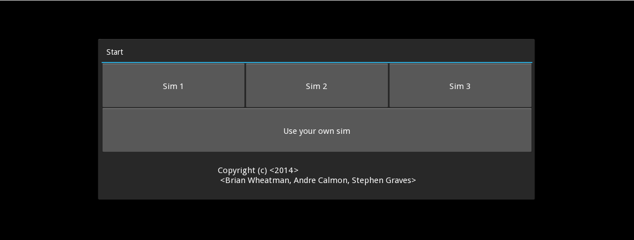From here you have 4 options, three different simulations that are designed for you, and one that you can design yourself.

For an example, I will use Sim 1, which opens to the following screen.

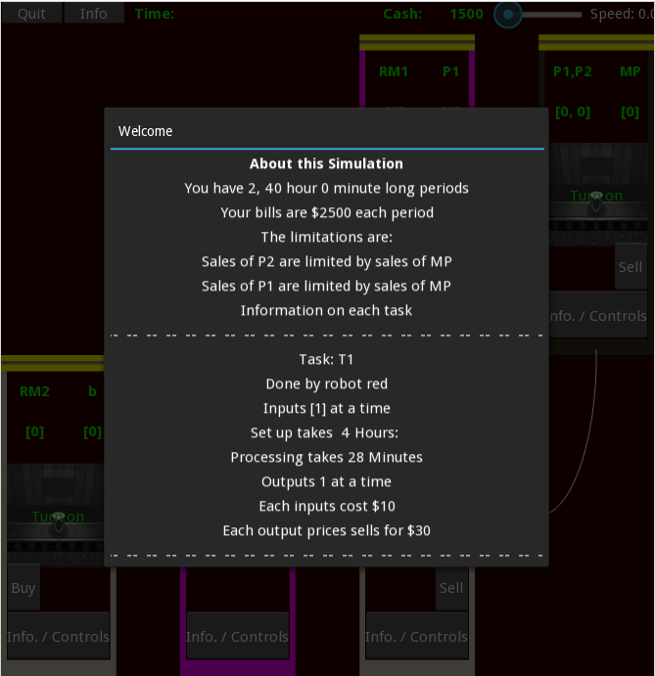This view tells you the information about this specific simulation.

* How many time periods there are.
* How long each time period is.
* The cost of a time period.

Which is automatically billed at the end of each period

Your sales limitations.

Information about each task including:

Which Robot

Inputs at a time

Set up time

Processing time

Outputs at a time

Cost of inputs

Cost of outputs

(scroll to view the rest of the tasks)

To start, click out of the welcome popup, and you will see the following view.

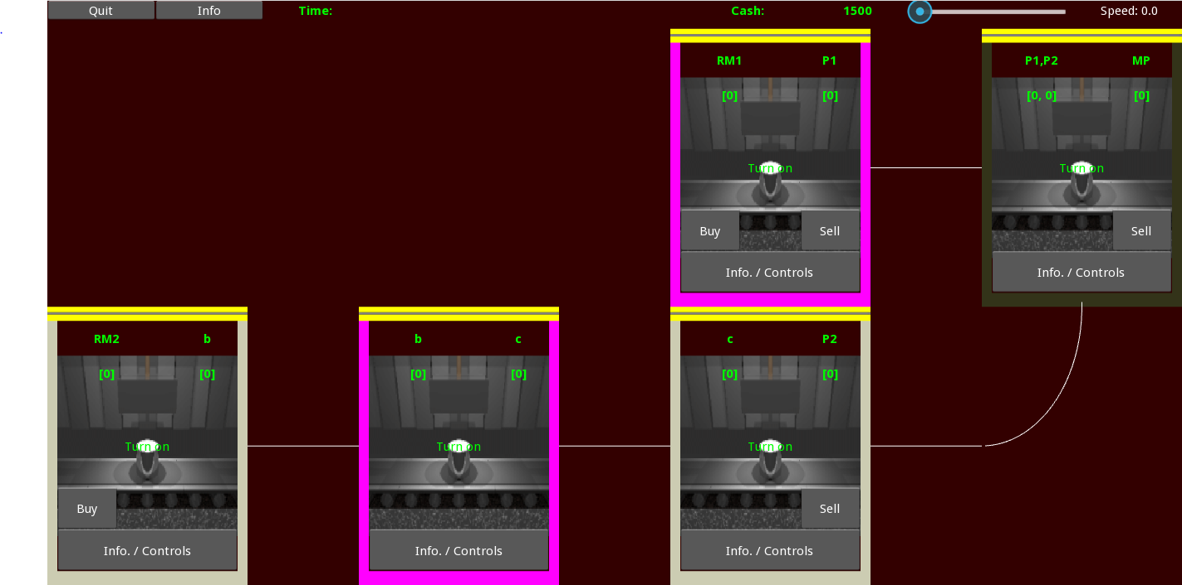

This view has two separate parts, along the top are controls that deal with the entire simulation, and the rest of the screen shows the different tasks throughout the factory.

The factory is shown as a tree from inputs on the left to outputs on the right, intermediaries flow from task to task along the white lines existing tasks on the right and entering on the top, bottom, or left. The color of the task shows which robot completes each task, if two different tasks are done by the same robot, they cannot be completed at the same time.

The controls along the top include “quit” “info” and “speed”. “Quit” allows you to stop the game at any time. “Info” will give you information and statistics about your run of the simulation. “Speed” controls how fast the simulation progresses, to start simply slide the speed slider to any position other than 0. Also along the top you will see you current amounts of money and the current time.

Each individual task gives you controls that enable you to work with that task specifically

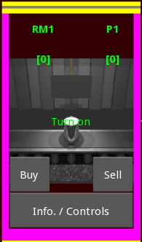In the top left and right corners, you will see information about the inputs and outputs respectively, including both their names and how many there currently are in that queue.

The top bar shown here in yellow, will change to green when the task has been set up, and there is a blue loading bar to show how close it is to either finishing set-up, or finishing processing an item.

If you click in the center the task will turn on, and you will be able to see that it is on, because the picture will turn into an animation, and the words ill change to turn off.

At the bottom you have the ability to buy the inputs and sell the outputs, if those inputs and outputs can be bought and sold.

At the bottom of each task you see a button that says “Info. / Controls.” This button allows you to access more controls for the task.

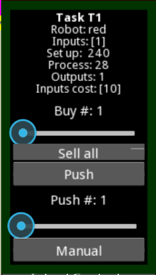This menu will open up when that button is pressed.

At the top it will show the information about the task.

Below that it enables you to be able to buy more than one item at a time. Simply set the slider at any value between 1 and 100 to buy that amount.

“Sell all” allows you to sell as many items in the output queue as you can.

“Push” moves the items in the output queue to the input queue of the next task. Again you can set how many you want to do at a time using the slider. Also if one task outputs to two different tasks, then here is where you will find the controls for which task it will push to. Below that you will find a button that here says “Manuel” clicking this which switch it to “Auto” which means that everything in the output queue will automatically be pushed forward.

At the end of each period a popup will show you how you are doing.

The game will end when you either run out of time, can’t pay your bills, or press quit. When the game ends you have the option of saving, which will save a file of how you did in the same directory as the game, and the option to reset, which will bring you back to the first screen.